Enhancing Paddy Crop Quality Through Object Detection Techniques
Sandeepanie, W.D.N¹, Rathnayake, S² ,Gunasinghe, A³
¹Sri Lankan Institute of Information Technology, sandeepanien@gmail.com
²Sri Lanka Institute of Information Technology, samadhi.r@sliit.lk
³Sri Lankan Institute of Information Technology, amali.g@sliit.lk

Abstract
Rice is a crucial staple crop globally, providing over half of humanity's caloric intake. It supports the livelihoods of small-scale farmers and landless labourers worldwide. With the growing population, there is a high demand for rice production. Sri Lanka is renowned for its high-quality rice and has a long history of paddy cultivation. However, not all of the country's 708,000 hectares of land dedicated to paddy cultivation are utilized due to water scarcity and unstable terrain.
The objective of this project is to enhance the quality of the paddy crop during its vegetative phase by early identification of diseases through the utilization of emerging technologies. The vegetative phase constitutes a critical stage in the growth of paddy, exerting significant influence on the overall yield, resistance to pests and diseases, nutrient assimilation, and the environmental implications of agricultural practices. The primary emphasis of this project is to identify diseases to which paddy crops are susceptible during the vegetative phase and subsequently present a visual representation of their locations on a map, serving as the output for end-users.
Early identification of paddy diseases is crucial for effective crop management and high yields. These diseases, caused by different pathogens, can significantly hinder plant growth and productivity if not detected and treated promptly. Identifying them early allows farmers and experts to take timely and targeted actions, like applying suitable fungicides or implementing cultural practices, to control their spread and minimize crop damage.
Keywords—machine learning, object detection, web development, YOLO v8, diseases, paddy cultivation.

Introduction

The paddy crop undergoes a comprehensive lifecycle encompassing seven distinct stages, as illustrated in (Fig. 1). These stages include the Pre-planting stage, Planting stage,
Vegetative stage, Reproductive stage, ripening stage, Harvesting stage, and post-harvest stage. The initial phase,
known as the Pre-planting stage, involves meticulous land preparation and the careful selection of suitable seed varieties. It encompasses tasks such as land plowing, leveling, and irrigation. Subsequently, the second stage entails either direct seeding or transplanting of the chosen seeds. The ensuing Vegetative stage marks the commencement of the paddy plant's growth. During this phase, leaves emerge from the shoot apex, and the root system undergoes development. Notably, the Vegetative stage is crucial for the successful growth and development of paddy plants as it facilitates photosynthesis and stem elongation. It lays the groundwork for the subsequent stages of the plant's lifecycle. In our project, we have specifically chosen to focus on the pivotal Vegetative phase and have selected the 'Broadcasting method' for planting, as depicted in (Fig. 2), to set the project's scope. Object detection plays a crucial role in identifying diseases in paddy crops. By employing advanced computer vision techniques and machine learning algorithms, object detection systems can analyze images or video footage of paddy fields and accurately detect signs of diseases or infections. The system can identify specific symptoms such as discoloration, lesions, or unusual growth patterns on the leaves or stems of paddy plants. With the help of object detection, farmers and agricultural experts can quickly and efficiently assess the health status of paddy crops over large areas, enabling them to take timely actions to prevent the spread of diseases.
This project proposes a way to recognize diseased crops using an object detection technique. The pre-identified diseased crops or the clusters of crops with symptoms will be displayed using a map to the end user. Additionally, a high-level overview of the spread of the diseases inside a chunk of land will be provided to the end user. During the vegetative phase, rice plants are vulnerable to a range of diseases, including Blast, Tungro, Sheath Blight, Bacterial Leaf Blight, and Brown Spot. These diseases can cause significant damage to the plants, reducing their ability to photosynthesize and produce healthy grains. In severe cases, they can even lead to plant death. Therefore, pre-identification of diseases in a paddy field during the vegetative phase is important to prevent or control disease, improve crop yields and quality, and make informed decisions about inputs and management practices.

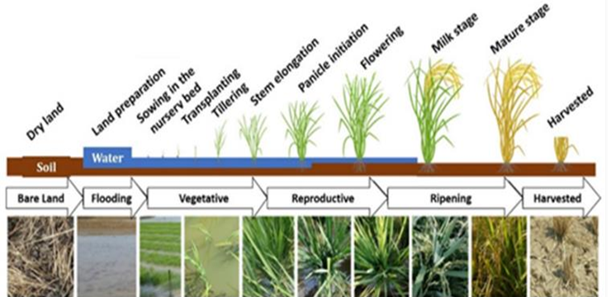

Fig. 1: six major phases of paddy cultivation in vegetative phase
https://www.mdpi.com/2077-0472/12/12/2137

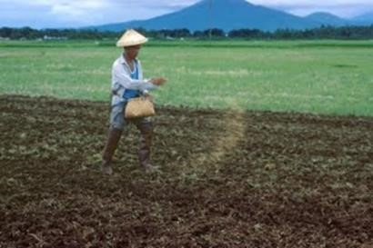

Fig. 2: paddy broadcasting method
http://www.knowledgebank.irri.org/step-by-step-production/growth/planting/direct- seeding

Conceptualization and Hypothesis Development

The researchers delved into the realm of diagnosing paddy diseases using machine learning, critically reviewing existing methodologies.
Enhanced Plant Disease Recognition Model:
An advanced plant disease recognition model was developed using the YOLOv5 network model. The model incorporated an 'InvolutionBottleneck' module to reduce parameters, an SE module to enhance feature sensitivity, and a modified loss function to address degeneration. Validation using sample images demonstrated a 70% mean average precision, surpassing the original YOLOv5 network by 5.4%. Notably, the model accurately identified specific diseases like powdery mildew and anthracnose with precision values of 86.5% and 86.8%, respectively. This enhanced YOLOv5 network outperformed other models, serving as a technical reference for plant disease prevention.

Strawberry Powdery Mildew Detection:
Addressing the impact of strawberry powdery mildew on yield, a computer vision algorithm was proposed. The model, DAC-YOLOv4, replaced the YOLOv4 backbone and neck with depth-wise convolution and a hybrid attention mechanism. This modification reduced the model size while maintaining performance, achieving a mean average precision of 72.7%. Notably, DAC-YOLOv4 demonstrated real-time detection on embedded platforms, providing an effective solution for early detection and prevention of strawberry powdery mildew.

Rice Disease Classification:
Focusing on common rice diseases, the Candy algorithm utilized improved Canny operator filtering. The ICAI-V4 neural network, based on the Inception-V4 backbone with a coordinate attention mechanism, effectively captured features and classified similar images. With a 95.57% average classification accuracy, this method proved robust in addressing challenges such as noise and blurred edges. The study contributes to the feasibility of rice disease classification in real-life scenarios.

Leaf Disease Detection using YOLO v7:
Leveraging YOLO v7 and a deep CNN, the proposed system aimed at accurate classification of leaf diseases. Incorporating GPT-3 for correction methods, the system showcased potential for early detection and correction of diseases, ultimately reducing crop losses. The integration of AI technologies holds promise for advancing agriculture practices.

Automated Rice Kernel Defect Detection:
A novel approach using the YOLO algorithm was proposed for automated detection and classification of diverse rice kernel defects. The system efficiently identified and categorized defects such as broken, spotted, yellow-colored, mass-chalky, and partial-chalky kernels. This innovative application of deep learning techniques offers an efficient solution for the quality assessment of rice.

Machine Learning Models for Paddy Plant Disease:
Highlighting the utilization of ResNet 50 as an accurate model, the literature underscores the potential for improved accuracy in disease detection. Hybrid models combining various architectures show promise, contributing to the evolving landscape of machine learning in agriculture.

Automated Detection of Rice Diseases:
Various machine learning techniques, including Tensor Flow Inception v3, demonstrated high accuracy in detecting diseases such as Brown Spot and Leaf Blast in rice crops. The studies support the quick action required for crop protection, emphasizing the role of technology in agriculture.

Transfer Learning for Paddy Plant Disease:
Utilizing a modified VGG19 model with transfer learning, the proposed method achieved an impressive average accuracy of 96.08%. This approach outperformed similar models in the literature, showcasing the potential of transfer learning in enhancing the accuracy of plant disease detection.

AI and Computer Vision in Rice Crop Health:
The literature discusses diverse approaches, including Bayes hypothesis and SVMs, for automated disease identification and classification in rice crops. These studies contribute to the automation of disease detection and classification, alleviating the challenges posed by manual labor.

Object Detection for Clothing Defects:
Focusing on addressing challenges faced by blind individuals in managing clothing, the study proposed an object detection system using the YOLOv5 model. The system demonstrated high average precision in detecting and categorizing stains on garments, offering a potential solution to assist visually impaired individuals in clothing selection.

Overall Significance:
The collective literature underscores the transformative impact of advanced models and deep learning techniques in revolutionizing disease detection across various crops. These approaches not only contribute to early detection and prevention but also pave the way for automation in agriculture, enhancing overall efficiency and productivity.

Methodology

Crop diseases pose a significant threat to agricultural productivity and food security worldwide. Timely identification and management of these diseases are crucial to mitigate losses. In this research, we focus on disease identification in paddy crops, utilizing the Osmo V3 device for image collection and the YOLO v8 algorithm for automated disease detection. The objective is to develop an accurate, efficient, and scalable solution to aid farmers in early disease detection and effective crop management.

- Dataset Collection:
To build a robust disease identification system, a diverse and representative dataset is essential. We collected an image dataset comprising around 5000 high-resolution images of paddy crops, captured using the DJI Osmo V3 device. (Fig. 3) and a smart mobile phone (Fig. 4). The gimbal stabilization system of the Osmo v3 device helps reduce camera shake, allowing for smoother and more professional-looking shots. The device is particularly useful when capturing footage from moving vehicles or when walking through uneven terrain. Although drone is a matching solution for the given scope, the wind generated by the drone's propellers potentially affects the quality of photographs taken while flying over a paddy field. This movement results in blurry or distorted images, especially if the exposure time of the camera is relatively long. In order to get the expected output from the system, the images are recommended to capture in row wise. (according to a pre-defined pattern) In brief, the capturing process should be done according to a pattern. The primary rationale for adhering to a specific capturing pattern lies in the facilitation of a systematic nomenclature for the images. This adherence ensures that the captured images are automatically arranged in a sequential order, thereby simplifying the process of identifying specific locations within the paddy field. The images were acquired from various geographical locations and encompassed different stages of disease progression.

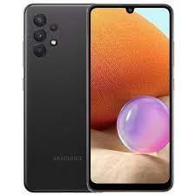
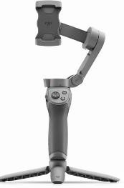

Fig. 3: DJI Osmo V3 Fig. 4: Smart Mobile Phone

- Labeling the Dataset:
The labeling process involved annotating or marking objects of interest within the images with bounding boxes and corresponding class labels. In this case, the exact places infected by diseases were bounded using a box.

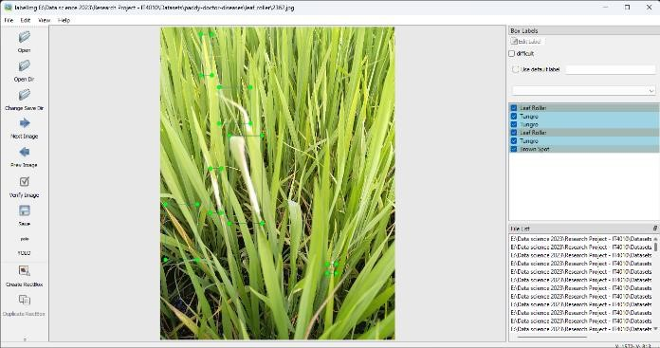

Fig. 5: Data Labeling Interface

After bounding the affected areas, the disease type related to the bounded box should be chosen using a drop-down list. For the labeling process, I’ve chosen an inbuilt labeling software specialized for YOLO algorithm.

- Preprocessing and Augmentation:

To enhance the quality of the dataset and to improve the generalization ability of the model, preprocessing and augmentation techniques were applied. Noise reduction techniques, such as image denoising and contrast enhancement, were employed to improve image clarity. Data augmentation techniques, including random rotations, flips, and translations, were applied to increase the dataset's diversity and robustness.

- Selecting suitable model:

The preprocessed data is then divided into three major categories known as ‘Train’, ‘Test’ and ‘Valid’ to be deployed in the YOLO v8 (You Only Look Once Version 8) model. The training dataset is used to train the YOLO v8 model. It consisted of a large number of labeled images, where each image is annotated with bounding box coordinates and class labels for the diseases present. The test dataset is used to evaluate the performance of the trained YOLO v8 model. It contained a separate set of images that are not seen during the training process. The validation dataset is used to fine-tune the hyperparameters and monitor the training progress.
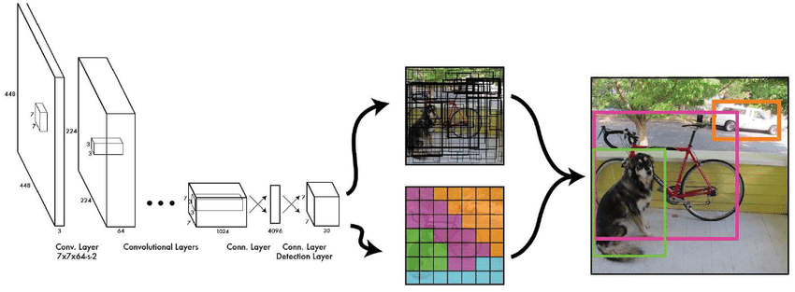
The reason for choosing YOLO V8 is due to its state-of -art performance and real-time processing capabilities. YOLO v8 utilizes a single deep neural network to simultaneously predict bounding boxes and class probabilities in a single pass. (Fig. 6) This architecture enables fast and accurate detection, making it suitable for large-scale disease identification in agricultural settings.

Fig.6: YOLO V8 Model Architecture
- Training and Model Development:

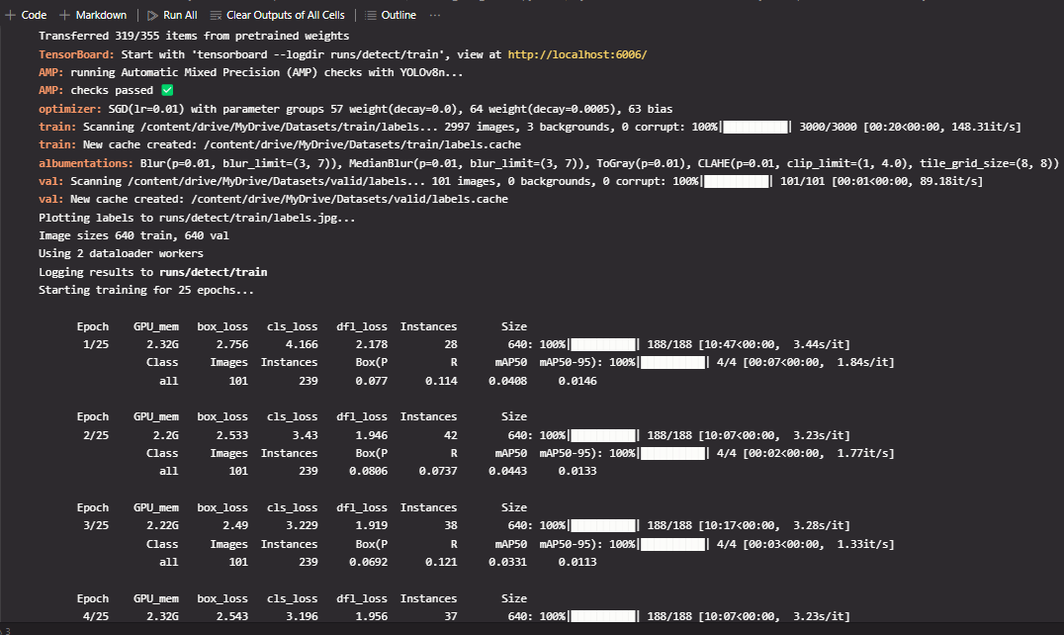
First installed the necessary libraries and dependencies such as ‘OpenCV’, ‘Numpy’ and ‘Matplotlib’. Then cloned the Yolo V8 repository existing in Github to a local folder in the machine. Defined the YOLOv8 configuration and downloaded the pre-trained weights. Then, loaded the YOLOv8 model and labels while providing the number of epochs. The Yolo V8 model is compatible with arbitrary sized images as long as both sides of the images are multiple of 32. Therefore, in this case image resizing techniques were not applied. (Fig. 7) (Fig. 8)

Fig. 7: Model Training Interface
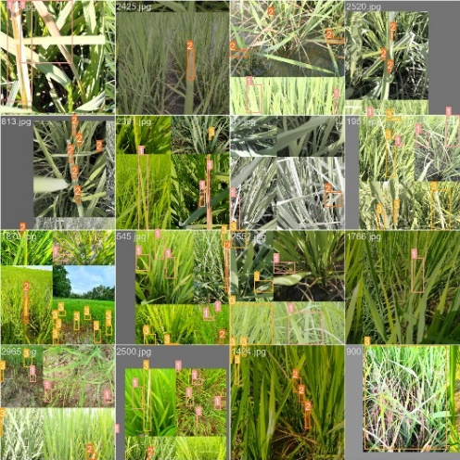

Fig. 8: Results after training

- Performance Evaluation:

To assess the performance of the developed model, a separate code was written based on the testing image set. A set of testing image data set affected by diseases, bounded by a frame with an accuracy score of identifying the disease was get as the output of the code. (Fig. 9) Additionally, visual inspection of the detected bounding boxes and class predictions was conducted to analyze the model's performance qualitatively. A performance test with few parameters is carried out to test the accuracy of the model.

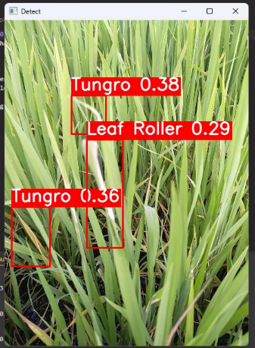
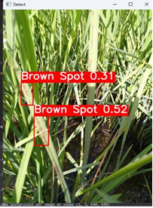

Fig. 9: Disease Identification and Accuracy Levels

As the first parameter, ‘precision’ was considered as a measure of the accuracy of positive predictions. In the context of object detection, it represents the proportion of predicted bounding boxes that contain objects of interest (true positives) out of all predicted bounding boxes. (Table.1)

Precision = TP / (TP + FP)

The second parameter was ‘recall’ and used to measure the proportion of actual positive objects that are correctly identified by the model. (Table. 1)

Recall = TP / (TP + FN)

Third parameter is metrics/mAP50(B): Mean Average Precision and calculates the average precision at a detection threshold of 0.5. (Table. 1)

metrics/mAP50-95(B): mAP50-95 calculates the average precision over different confidence thresholds ranging from 0.5 to 0.95.(Table. 1)

val/box_loss: Box loss measures the discrepancy between the predicted bounding box coordinates and the ground truth box coordinates. Further, it quantifies the localization accuracy of the model. (Table. 2)

val/cls_loss: Class loss represents the error in predicting the object class labels. It captures the accuracy of object classification. (Table.2)

val/dfl_loss: DFL (Dynamic Feature Learning) loss is specific to YOLO models and is used to optimize the feature learning process. It helps in adapting the network to better represent the features of objects of different scales and aspect ratios. (Table. 2)

Table 1: Metrics used to measure the accuracy of the model.
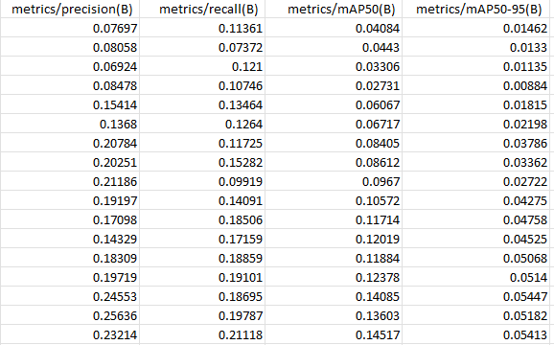

Table 2: Metrics used to measure the accuracy of the model.
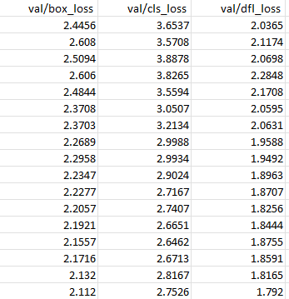

Automatically generated graphs depict (Graph of correlogram and graph of Dispersion) the distribution of various diseases among the given images of the dataset.
(Fig. 10)

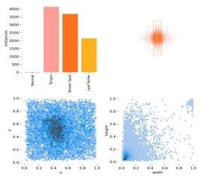

Fig. 10: Auto Generated Graphs

Moving beyond static images, our system incorporates real-time video analysis for dynamic disease monitoring. The Osmo V3's versatility shines in capturing real-time footage, ensuring a seamless transition from static to dynamic disease identification. The logical mapping process unfolds as the algorithm sifts through video frames, providing a comprehensive view of disease progression.

Upon successfully developing the disease detection model, a computation is incorporated to determine the prevalence rate of each disease within a designated land area.

For each selected disease in a specific plot of land, a corresponding percentage value of the infection is generated. The ultimate outcome is then visually represented on a map that is integrated into a web application. (Fig. 11)

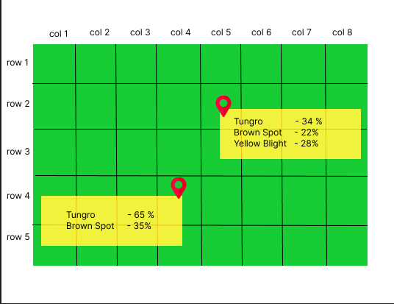

Fig.11: Web Interface depicting diseases and their percentage levels.

Results and Discussion

In the proposed research, YOLO V8 model was trained for 16 epochs. In most of the images, the diseases on the leaf blade are visually imperceptible. Although the symptoms of the diseases are in micro level, YOLO V8 algorithm was able to distinguish them approximately.

Additionally, the proposed model was able to work fine with multi scaled images. (Fig. 12)
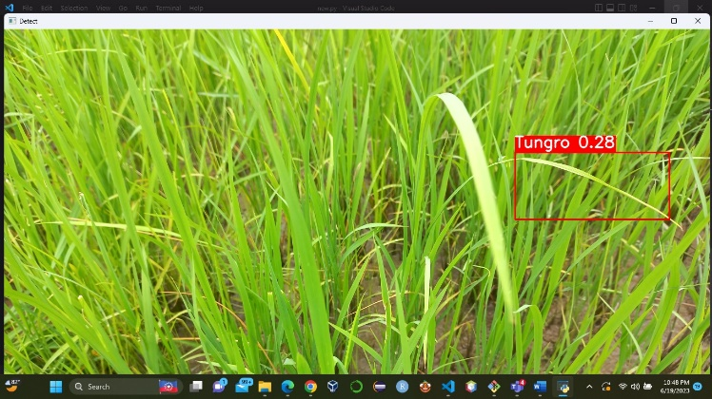

Fig. 12: Identification of diseases in multi scaled images.

To increase the precision and recall values generated by the model, the researchers wish to adjust the model architecture and parameters further. Additionally, the model training process will be optimized by applying techniques like gradient clipping and weight decay to prevent overfitting. While the YOLO v8 algorithm demonstrated promising results in disease detection and classification, it is essential to acknowledge its limitations. The algorithm's performance might be affected by variations in lighting conditions, image quality, and the presence of occlusions. Additionally, the dataset used in this study focused on a limited number of common diseases, and further research is needed to expand its applicability to a broader range of diseases in paddy cultivation. Future work should also explore the integration of remote sensing techniques and other advanced machine learning algorithms to enhance disease detection accuracy and scalability.
The research has significant implications for both the scientific and agricultural communities. Scientifically, it introduces innovative disease identification techniques in paddy crops, leveraging advanced technologies such as the YOLO v8 algorithm. The comprehensive dataset collection and labeling methodology contribute to dataset standardization, providing a benchmark for future studies. The rationale behind selecting the YOLO v8 model and the utilization of diverse performance metrics enhance the methodological rigor in assessing disease identification models. The suggestion to explore remote sensing techniques signifies a forward-looking approach. In the practice community, the research facilitates early disease detection for agricultural practitioners, enabling timely interventions and aligning with the principles of precision agriculture. The computation of disease prevalence rates and their visual representation on a map within a web application provides a practical tool for farmers. The user-friendly solutions, including the use of a smart mobile phone and interfaces for data labeling, make the technology accessible. Overall, the research bridges scientific advancements with practical applications, offering valuable tools for improving crop management and reducing losses in agriculture.

Acknowledgement
I express my sincere gratitude to the following individuals and institutions for their valuable support and contributions to our research project.
Firstly, I thank the Yakkala Govijana Sewa Center, Bathlegoda Rice Research Institute, and Pelwehera CIC Agro Business Farm for providing resources and facilities for our research. Their cooperation and assistance were crucial for our experiments.
I’m deeply grateful to my supervisor, Mr. Samadhi Rathnayake for his guidance, expertise, and constant encouragement. His insights and feedback significantly shaped our research.
My co-supervisor, Mrs. Amali Gunasinghe, deserves my appreciation for her valuable input and support in refining my research methodology and addressing challenges.
I also acknowledge the staff members and colleagues who provided assistance and support throughout the project. Their collaboration and expertise greatly contributed to my success.
Lastly, I extend my gratitude to the research participants who volunteered their time and provided valuable data.
I’m humbled by everyone's efforts and remain indebted to each and every one of them for their contributions.

References
[1] Wang, Y., Wang, Y., & Zhao, J. (2022). MGA-YOLO: A lightweight one-stage network for apple leaf disease detection. Frontiers in Plant Science, 13. https://doi.org/10.3389/fpls.2022.927424
[2] Li, Y., Jian-Chun, W., Wu, H., Yu, Y., Sun, H., & Zhang, H. (2022). Detection of powdery mildew on strawberry leaves based on DAC-YOLOv4 model. Computers and Electronics in Agriculture, 202, 107418. https://doi.org/10.1016/j.compag.2022.107418
[3] Tang, Z., He, X., Zhou, G., Chen, A., Wang, Y., Li, L., & Hu, Y. (2023). A precise Image-Based tomato leaf disease detection approach using PLPNET. Plant Phenomics, 5. https://doi.org/10.34133/plantphenomics.0042
[4] Peng, Y., & Wang, Y. (2022). Leaf disease image retrieval with object detection and deep metric learning. Frontiers in Plant Science, 13. https://doi.org/10.3389/fpls.2022.963302
[5] Gong, X., & Zhang, S. (2023). An analysis of plant diseases identification based on deep learning methods. Plant Pathology Journal (Suwon), 39(4), 319–334. https://doi.org/10.5423/ppj.oa.02.2023.0034
[6] Kundu, R. (2023, April 20). YOLO: Algorithm for Object Detection Explained [+Examples]. V7. https://www.v7labs.com/blog/yolo-object-detection
[7] Khan, S., Tufail, M., Khan, M. T., Khan, Z. A., Iqbal, J., &amp; Wasim, A. (2021, April 1). Real-time recognition of spraying area for UAV sprayers using a deep learning approach. PloS one. https://www.ncbi.nlm.nih.gov/pmc/articles/PMC8016340/
[8] Ultralytics. (n.d.). Home. Ultralytics YOLOv8 Docs. https://docs.ultralytics.com/
[9] Development of a recognition system for spraying areas from unmanned ... (n.d.). https://www.researchgate.net/publication/330379589_Development_of_a_Recognition_System_for_Spraying_Areas_from_Unmanned_Aerial_Vehicles_Using_a_Machine_Learning_Approach

[10] Skalski, P. (2023, October 3). Train yolov8 on a custom dataset. Roboflow Blog. https://blog.roboflow.com/how-to-train-yolov8-on-a-custom-dataset/
[11] Rath, S. (2023, March 7). Yolov8 ultralytics: State-of-the-art yolo models. LearnOpenCV. https://learnopencv.com/ultralytics-yolov8/
[12] Liu, J., & Wang, X. (2021, February 24). Plant diseases and pests detection based on Deep Learning: A Review - Plant Methods. BioMed Central. https://plantmethods.biomedcentral.com/articles/10.1186/s13007-021-00722-9
[13] Vemuri, M. (2020, April 16). Evoke disrupt AI 2019 Hackathon: Using NLP to predict diseases. Medium. https://medium.com/@m_vemuri/evoke-disrupt-ai-2019-hackathon-using-nlp-to-predict-diseases-9bb3c3590735
[14] Faster R-CNN based rice leaf disease detection method - researchgate. (n.d.-b). https://www.researchgate.net/publication/364817597_Faster_R-CNN_Based_Rice_Leaf_Disease_Detection_method
[15] Image processing techniques for diagnosing rice plant disease: A survey. (n.d.-c). https://www.researchgate.net/publication/340682681_Image_Processing_Techniques_for_Diagnosing_Rice_Plant_Disease_A_Survey

